Nivelamento Basic 2

# Circle the correct answers.

* 1. Do you like **Ecuador / Ecuadorian** food?
  2. Is your grandfather from **Vietnam / Vietnamese?**
  3. My sister spoke **Italy / Italian** when she was on vacation.
  4. Did you see the pyramids in **Egypt / Egyptian?**
  5. I **do / play / go** karate.
  6. My mother is **doing / playing / going** biking

# Look at the picture. Circle the correct words in the questions.

# Then write the answers with *It’s* or *They’re* and the price.

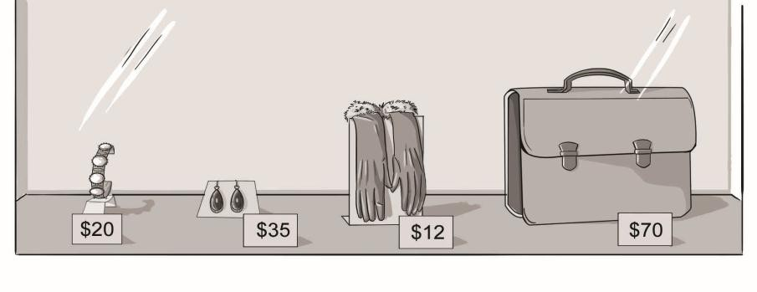

* 1. ***A*** How much **is this / are these** bracelet? c. ***A*** How much **is this / are these** gloves?

***B*** . ***B*** .

* 1. ***A*** How much **is that / are those** earrings? d. ***A*** How much **is that / are those** briefcase?

***B*** . ***B*** .

1. **Complete the paragraph. Use the *SIMPLE PAST* and the words in parentheses.**

**(0.5 each)**

Liz (go) to the movies last evening. She (want) to go to an outdoor concert, but it (rain), so she (change) her plans. After the movies, she (eat) a sandwich, (study) for a couple of hours. Then, it

(be) time to go to bed. She (sleep) for 8 hours.

1. **Complete the paragraph. Use *WAS,* *WASN’T*, *WERE* or *WEREN’T*. (0.5 each)**

I remember my first swimming lesson. I very old – only five – and I

very scared. I think the other kids nervous, too. But the teacher, Julie,

very nice. We loved her, but the swimming didn’t go very well. We

very good students, but Julie a wonderful teacher.

# Complete the sentences with *GOT* or *WENT*. (1 each)

* 1. Yesterday, I hiking with my friends. It was great, but it was really hot and sunny. I

a bad sunburn.

* 1. I on a road trip across the U.S. with my brother. It was awful. We both

sick! We had to stop and stay in bed for three days.

# Write the questions for the answers. (1 each)

*Example: A: How was your vacation ?*

*B: My vacation? It was fun!*

*Opções:*

*Where did you go?*

*Who did you go with?*

*What was the weather like?*

*How long were you there?*

1. *A:* ?

*B*:We went to New York.

2. *A:* ?

*B*: I went with my family.

3. *A:* ?

*B:* It was rainy, but warm.

4. *A:* ?

*B:* We were there for a week.

# Circle the correct words. (0,5 each)

1. *A* How ***much*** / ***many*** fruit do you eat a day?

*B* Well, I have ***banana / a banana*** every day for breakfast.

1. *A* How ***many / much*** times a week do your parents eat meat?

*B* They eat ***beef / beefs*** almost every day.

1. *A* Does your brother eat ***many/ much*** eggs?

*B* No, he doesn’t. I bet he eats ***egg / eggs*** about once a month.

# Complete the questions and answers. Use *SOME* or *ANY*. (0,5 each)

* 1. *A* Do you have fruit or snacks? I’m starving.

*B* No, but I have milk. You can have that.

* 1. *A* It’s so hot. Do you want to come to our house? We have ice cream.

*B* Sure. Do you have sprinkles? I love sprinkles.